# **BLOCKCHAIN, CRYPTOCURRENCY AND REAL ESTATE:**

**THE CURRENT SITUATION AND PROSPECTS FOR THE NEXT 5 YEARS**

By

Robert A. Simons, Ph.D.

Levin College of Urban Affairs, Cleveland State University

[r.simons@csuohio.edu](mailto:r.simons@csuohio.edu)

and

Samuel T. Simons

Smith School of Business, University of Maryland, College Park

ssimons@umd.edu

A paper presented at the Annual meeting of the American Real Estate Society,

Noplace, Zoomland March 2021.

**ABSTRACT**

Blockchain technology is a platform for transactions and investment. It includes Crypto currencies, of which there are dozens of investment vehicles, of which Bitcoin and Ethereum are the best known. Crypto is an emerging asset class, and offers some portfolio diversification benefits, as well as attractive rates of return, subject to “translation” or conversion back into underlying currencies like the US dollar. Blockchain allows ease of access and transparency, but also provides a cloak of anonymity, which may be incompatible with owning real estate, which generally has ownership and transactions as public records.

This paper provides a brief primer on the intersection of blockchain, cryptocurrencies and real property, and reviews the various ways that these emerging technologies and instruments are used in real estate investment today. We investigate a blockchain-oriented investment platform, RealT, and report on their business model and customer-servicing interface. Their model offers tokenized real estate to a wide range of qualified investors, and many of the occupied houses feature secure cash flows in the form of Section 8 tenants. If properly developed, the model appears sustainable, and has the potential to rejuvenate inner-city residential property markets. and could open the door for a greater role for not-for-profit groups.

# **Lit Review**

Robert Leshner and Geoffrey Hayes. Compound: The Money Market Protocol. Feb. 2019. url: [https://compound.finance/documents/Compound. Whitepaper.pdf](https://compound.finance/documents/Compound.%20Whitepaper.pdf).

This whitepaper was the beginning of compound finance, an algorithmic money market protocol that lets users lend and borrow idle assets in the blockchain. Utilizing a new coding language at the time, solidity, Hayes, Leshner and Compound Labs, created a platform with over $10 billion locked in as of March 5, 2021. On compound Finance there are three stable stablecoins, or digital dollars with active money markets, enabling users to deposit bitcoin, ether, and few other assets to borrow and lend effetely allowing users around the world leverage their investments and access capital. While Compound Finance was certainly not the first Decentralized Finance project and will not be the last, the team’s willingness and promotion of community governance has created a new era of “self-driving banks”

*Hayden Adams. Uniswap. url:* [*https://uniswap.org/docs/*](https://uniswap.org/docs/)

Born out of the ICO (Initial Coin Offering) era which lead to Bitcoin’s large crash in 2018, authors of the Uniswap Whitepaper created the frameworks to allow for algorithmic, decentralized exchanges. Instead of utilizing orderbooks as traditional exchanges do, Uniswap allowed third parties to provide and remove liquidity to markets, without any governmental regulation or regulations. Prices are determined by a constant product formula, relying on liquidity providers and arbitragers to keep the market in equilibrium.

<https://dashboard.realt.ch/map>

This website uses public blockchain data to create an interactive dashboard for RealT investors and those curious. Provides maps, trading data and rental disbursements.

<https://defipulse.com/>

Data aggregation website putting together all financial holdings of decentralized finance platforms.

# **INTRODUCTION**

Bitcoin’s meteoric rise is well known but it is one of many cryptocurrencies, which is in part subsumed under blockchain technology. These have achieved prominence but are still highly controversial: depending on whom you talk to, blockchain and cryptocurrency either herald a revolutionary new approach to commerce or raise the specter of rampant speculation and corruption. Nevertheless, these innovations have made massive strides toward mainstream adoption. Major firms such as J.P. Morgan, Facebook (Libra, now Diem) and Alibaba have launched stablecoins (digital dollars) to allow seamless digital payments. Central banks the world over are considering the tokenization of their fiat currencies. When applied to the appropriate applications, blockchain technology has proven its ability to deliver concrete advantages such as security, anonymity and transparency over traditional system management systems. We address how blockchain or cryptocurrencies (crypto), or both, are compatible with ownership of real estate in the US. What models exist, and which are likely to emerge soon? We focus on tokenization (securitization) of real estate, and how it can be originated, brought under a blockchain management system, provide returns to investors yet also provide scalable returns to property originators (owners of housing rental units) and blockchain management companies. We also look at potential social benefits to the communities that host clusters of these tokenized properties.

The real estate market is a prime target for blockchain because it can be managed publicly, even though individual ownership units are pseudo-anonymous (The issuing party has done KYC, but to a public onlooker, all they can see is an address). Crypto’s disruptive potential is primarily as a very fast-growing medium of exchange that appears to offer some potential tax advantages, sports a wealth of information that is normally publicly accessible, relies on clearly defined contracts to complete transactions, and can be adapted to become highly liquid. In this context, the integrity-protected data storage and process transparency offered by blockchain technology is potentially a very good fit for the real estate industry, while crypto is more of a sidebar.

# **BLOCKCHAIN OVERVIEW**

The Blockchain is a set of separate computers that work together to maintain a ledger, or list of transactions. It can do whatever a regular computer can do, albeit slower, but more secure. Bitcoin, built on the first blockchain is essentially a numbered bank account, but all transactions are publicly broadcasted. Ethereum, the largest blockchain, allows for users to send executable code along with transactions. These are called “Smart Contracts” and allow for programable money and assets. Everything that has been sent is irreversible and permanent. Here is the timeline for blockchain development, coterminous with bitcoin, the most visible and highly capitalized cryptocurrency.

## **Cryptocurrencies Overview: Myth vs. Reality**

Bitcoin and Ethereum are two of the most well publicized crypto currencies, but there are dozens of others, all filled with FUD (Fear, Uncertainty, Doubt). Below are some common misconceptions and rumors spread about digital currencies at large:

**Claim:** Bitcoin is anonymous. **Fact:** first level yes, but you can peel back the onion

**Claim:** Bitcoin has no intrinsic value. **Fact:** value is as value does – supply and demand

**Claim:** Crypto is used to evade taxes. **Fact:** perhaps, but tax avoidance and tax evasion are different. And most taxes are evaded with use of cash…and that is widely circulated.

**Claim:** Bitcoin is only used for illegal things. **Fact:** for every dollar in bitcoin laundered, $800 in American Dollars, specifically cash are laundere**d**

These claims/myths have been propagated from everybody from large banks, short sellers and most importantly, the ignorant. To give some background about bitcoin and more importantly fiat currency, for every dollar in bitcoin laundered, $800 in American Dollars, specifically cash are laundered. (CoinTelegraph).

But what even is fiat currency? Where do we derive value for fiat currencies? What is a cryptocurrency?

Well, to keep it short, bitcoin is a digital store of value, tied to an alphanumeric string, or an address. Like swiss numbered bank accounts, at the end of the day it is not anonymous. Whatever exchange you created your wallet on, the people that you have sent and received bitcoin from can rat you out. If the federal government, a hacker, or a North Korean wants to find out who is associated with a given address, they can and will.

# **Centralized vs Decentralized Finance and Real Estate Investment**

Out of the financial revolution and technological progress bitcoin brought forward, a new financial system has arisen, based on blockchain technology and decentralization. The traditional, centralized and predominant public real estate investment platform is the REIT (Real Estate Investment Trust). The REIT is a securitization of a real estate portfolio that is publicly listed on many securities exchanges, and has been popular with institutional and retail investors alike to gain exposure towards real estate markets and their cash flows. While REITs can feature both debt and equity, we focus on the equity side here, acknowledging there are other ways to invest in real estate debt (CDOs, Fannie Mae, etc.).

Historically speaking, the REIT has been incredibly successful. Based on the technology at the time, REITS have allowed exposure towards real estate markets to individual, non-accredited investors on a centralized public exchange. Because funds and entities can be listed on a public stock exchange, the liquidity for any given fund is astronomical compared to any private system. a stock exchange, specifically the NYSE can process hundreds of thousands of transactions a second, creating a technological race to the bottom, where firms compete on how fast they can fill orders, measured in the millisecond. For example, Goldman Sachs has spent hundreds of millions of dollars in infrastructure investment to shave 21 milliseconds off their transaction speeds (CNBC). But this is not innovation in finance, this is simply a race to the bottom. Instead of creating a new system where front running and payment for order flow are no longer the greatest money makers, institution and academia has stayed put.

Look back at the 2009 financial crisis, who do we like to blame? The CDO. The Collateralized Debt Obligation, an asset backed security, was the best friend of many in the financial sector, both in universities and on wall street. Academics and professionals devised a new technology that allowed the packaging of fixed income securities and paired it with a complementary derivatives market. Caught up in their own game, risks were overlooked, and due diligence ignored. The crash was based in the US, which had the world’s largest, most advanced, innovative and regulated financial markets. If government could not prevent rampant greed and market failure, then perhaps a non-governmental currency was the answer?

In the aftermath of the great recession in January 2009, Satoshi wrote on the first bitcoin transaction, “The Times 03/Jan/2009 Chancellor on brink of second bailout for banks." A new generation of finance was born.

So why are academics slow to adopt or champion this new tech? There are a few reasons:

* It’s a mix between computer science/cryptography and finance, not many people meet at the cusp between these two fields.
* New technologies take time to reach the front lines of leading journals.
* It opposes the Big Banks, and Central Government, the ones professors consult for; and
* Non tenured professors refuse to take a risk that large, while older professors are stuck within a generational gap, simply not understanding of “internet money”.

To understand the media and academia’s stance on digital assets, let us take a look at when different digital currencies and blockchain applications were created.

## **Timeline: Blockchain and Bitcoin evolved out of the ashes of the great recession.**

Exbibit 1: Timeline of blockchain development:

At this given moment, blockchain has yet to fully engulphed the centralized financial technology of the 20th century. Its speeds are too slow now to allow for a fully decentralized ledger. Even non-brokers and traders have utilized the fast transaction speeds that the information age has brough upon us, visa, for example relies on a network that can process 50k transactions per second allowing for secure and quick payment channels between millions of consumers and merchants, all seamlessly and in the background. Banks built on wires and ACH (Automated Clearing House) and SWIFT are “backed by the government” has its good and bad, but how does it compare to new technologies?

Below is a small overview of the technological underpinnings and use cases between centralized and decentralized finance.

Allow us to compare these two, now separating fields of study, the first being a macroeconomic perspective (Defi vs CeFi) and then from a microeconomic perspective (consumer standpoint).

|  |  |  |
| --- | --- | --- |
| **Feature** | **Decentralized finance (DeFi)**. Includes....... | **Centralized Finance (CeFi)** |
|  |  | Centralized Finance (Includes centralized bitcoin exchanges, clearing houses, banks and stock exchanges. |
| form of conveyance | Tokenization is an act from an asset owner placing their asset on a blockchain, so that anyone may interact as they please, from any system or computer | Securitization is an act of a centralized exchange placing a real-world asset on their computers and or ledger, so that others may trade within their system |
|  | Censorship resistant | Possible single point for failure |
|  | Can leverage multiple exchanges simultaneously | Backed up by government |
|  | Arbitrage available to all, more efficient markets | Can handle more transactions |
|  | Distributed ledger, harder to fail as a whole | Visa can do 50,000 transactions per second |
| start up costs | Inexpensive startup costs | High startup costs |
|  | Divisible, Fractional | Singular codebase or clearing house |
|  | Provable, “public” ownership | On a singular exchange, high cost of transfer |
| ownership |  |  |
| platform flexibility | Move between platforms and contracts | Locked within that platform |
|  |  |  |
|  | Many use cases | Comes complaint, as exchange does all the work |
|  | Utility, payment, debt, equity, ownership deed | |
|  |  |  |
| barrier to entry | Cheap to issue | Expensive to issue |

## **Smart Contracts**

Blockchain finance, a new implementation of distributed ledger technology has emerged as one of the biggest innovations in finance of the century. This technology relies on “Smart Contracts”, which can be thought as a lawyer sitting inside a vending machine (Schär 2020). This essential building block allows funds to be transferred, spent, lent or without manual intervention. By coding a smart contract, the user defines the parameters under which funds can be used, and when. Simple smart contracts can be used to facilitate over the counter trades between two parties, can allow timeclocks on funds, and can even facilitate complex trading and lending markets.

Right now, it may seem complex and overly complicated to explain how internet money transacts, and that is the nature of contracts, let the lawyer deal with it. Except in this situation, it is a programmer, a money programmer.

Within the context of RealT, shown later, the use cases of smart contracts will become apparent.

Exhibit 2

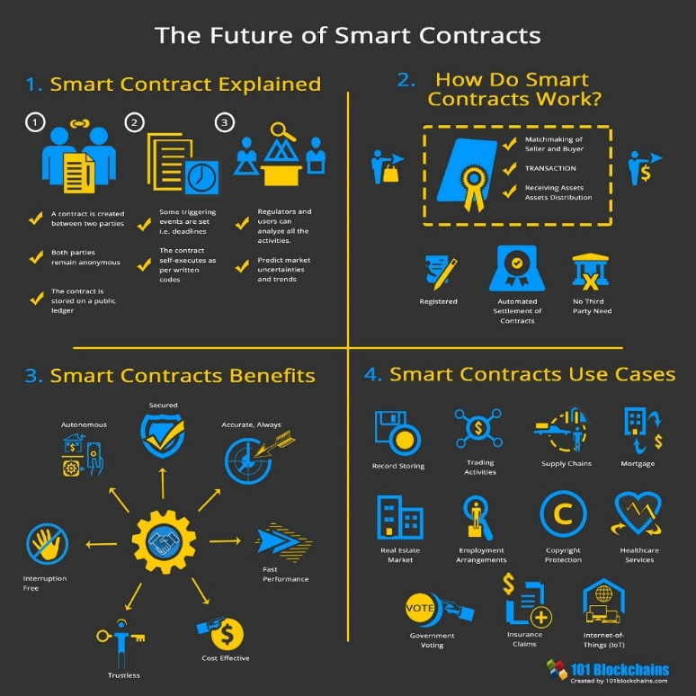

## Stablecoins: How are real world assets stored on the blockchain? The Digital Dollar

To understand how finance on the blockchain works, we must first delve into how value, i.e. USD, is stored on this system. We all have heard of how many digital assets like bitcoin are incredibly volatile and backed by little to inherent value. Outside of the cryptocurrency enthusiasts, there exist a small handful of well-established and regulated firms who have taken it upon themselves to bring stability towards the digital asset market. The products they have brought forth are referred to as stablecoins. A stablecoin, at least for the ones applicable to real estate can be backed by fiat currencies or by commodities.

For example, Paxos, a New York State-chartered trust company regulated by the New York State Department of Financial Services, has created two monumental products, Paxos Standard and Pax Gold (Cascarilla). Pax Gold was created to reduce the costs associated with owning and storing gold. Paxos bought a fixed supply of gold and sold the corresponding equity on digital exchanges. Paxos created only the number of shares as there were ounces in storage and the price was pegged at 1 PAXG = 1 oz of gold. Whatever the market price for gold is at any given time will be the price listed on the digital asset exchanges. Unlike greenbacks today, holders of the digital asset can redeem their shares for physical gold through Paxos, at any given time. Paxos, essentially an agent of the State of New York has been able to reduce the number of physical transactions of gold and has created a more secure and efficient storage process for the commodity.

Gold is simpler, and single commodity exchange traded funds have existed for a long time. Never had there ever been the demand for digital money. Yes, money is mostly digital at this time, but just like Pax Gold, digital money in banks was created to be withdrawn. Paxos took advantage of its money transmitter license and its earlier successes to bring digital dollars to the blockchain. The new service, called Paxos Standard, was a new, dollar backed, digital currency. This same service allowed for the digital ownership of fiat backed digital assets to be redeemed at Paxos immediately, just like a bank. Although it has many similarities with a bank, the one that sticks out the most is its lack of a fractional reserve model. For every dollar issued in value on the blockchain, there is a correlating dollar in the bank account held by Paxos. This means that at any given time given a bank run, Paxos would be able to service its liquidity with no problem.

## AMM- Automated Market Maker: Liquidity out of Thin Air

While in traditional markets only big players can take advantage of arbitrage and market making opportunities, Defi allows for the average people to collectively pool capital and algorithmically become a unified and profitable market maker (Egorov 2019)

In a typical order book market, there is what we call a bid and ask. There inherently must be a distance between these two numbers, otherwise both orders would find each other and be filled. When a new player comes into the market, they may place a limit order at any given price, or they can have their order fill instantly with a market order. For someone who wants to make money off the market, they must position themselves on both the buying and selling side of the order book. This way, no matter what kind of order, buy or sell, limit or market, the “market maker” will profit the difference between their positions, since they buy for less than they sell.

While this sounds technically sound, this market making method has a few problems, one being its inequity.  It required a very large amount of capital, computer and programming resources and close connections to the exchange computer (Williams, Peterson). Finish cites This is not something an individual with $20 dollars in the bank account can make money on.

Years later, blockchain developers created a system for the everyday man, one that does not require huge swaths of capital or immense technological capabilities. Meant to be able to provide liquidity to the everyday man this system does not facilitate order books (Adams 2020). Those who want to make money off trading will provide liquidity to a pool. This means that many individuals put assets together into one non-custodial fund that others make trades with. The money is made by chagrin around a 0.3% fee, which is typically the spread in any liquid market.

On the trading side, the swap price is set up with what is called a price oracle, a decentralized technological function that aggregates several exchange prices. From here, one who wants to create an order, or a swap will “call” the current market price and trade with a liquidity pool. The swapper pays a small fee to make the trade and they go on their way.

RealT uses Uniswap as a core part of their secondary market, allowing for liquid, trustless and pseudo-anonymous secondary market transactions. We shall see later that the trading pair one chooses can have an effect on the liquidity. If it’s a volatile asset, asset will be better priced and arbitraged will use RealT to buy and crypto sell crypto for a profit.

## Capital Markets

Because real estate investment is typically done with the help of external financing, either by a bank or by private individuals, creating leans and leveraging equity for more capital. Similarly, within decentralized finance, leverage is even more crucial and has been the focus of much technological development, this is the financing part of DEFI.

Now margin lending has been outside traditional banking for decades at this point, so the concept may not be fresh in everyone's mind. Let us say that you own one share of Apple stock. As a huge fan and a believer in the company's long-term performance, you do not wish to sell this asset anytime soon. So, your stockbroker introduces you to a man who does not think that Apple will perform well in the next few days. The man says to you, “I will pay you 5% APY to ‘borrow’ your security.” This man wants to short sell Apple, meaning he is going to sell the stock now and repurchase it later for cheaper. At the end of the period, he will return the stock to you with 5% yearly interest. You and the broker are protected by a margin, or collateral, a larger amount of liquid value held in the borrower’s portfolio. If Apple share price goes up, the borrower will have to add more collateral, or be forced to buy the stock back at a loss and forfeit his or her collateral. This is because the borrowed value has exceeded the allotted amount, and in order for the protocol to have its NAV positive, bad borrowers must be rooted out.

On the blockchain, this margin lending system has been created without the need for a trusted third party (like a lawyer or clearing house). A system called “Compound Finance” is a great example of this decentralized financial ecosystem (Leshner). Like margin lending, there are two parties at play, one going long, and the other going short. However, there is no broker, as this is done with pre-audited code called smart contracts. One party will post collateral, typically Ether, a popular cryptocurrency, and ask for a loan worth roughly 50% of the collateral value. The APY typically fluctuates with supply and demand, but it is usually around 10% APY. Another party will provide stablecoins to the borrower and collect the interest payment.

The collateral is managed by a system of computers known as keepers. They make sure that the collateral value is safe and will contact the borrower if there is a risk of liquidation. If there is ever a loan collateral that is reaching dangerous values, any individual may come in and purchase the debt. The purchaser is required to post the margin and in return they may redeem the underlying value.

So why would someone ever do this? Well unlike margin lending, there is no one going short. Because the other asset is a stablecoin, considered a risk neutral position, there is only one person going long. If someone really believes in Ether, they may be able to almost double their position by using this protocol. Now, if the price goes up, they will easily be able to pay from their profits. If it goes down, then the lender will benefit. Either way for the lender, this is a win-win.

As of July 30, 2020, there is around $2.7 billion dollars locked into these protocols, up over 100% the last few months. (Late February 2021, 35.14 Billion.) There have been many recent developments in this technology and a handful of capital firms and institutional investors heavily investing. For someone who is distrustful of banks and embracing the future, it is the place to be financially.

Below is a screenshot of AAVE, a large lending protocol with a little less than $10 Billion in its system. As you can see, there are 7 digital dollar markets. Other protocols such as Compound.Finance and MakerDao also employ “self-driving bank” technology.

Source: Aave.com

# **RealT CASE STUDY**

Real T is one of several known companies (i.e., Roofstack and Realblocks) marketing fractional tokenized ownership of residential properties on the www. RealT transactions are managed/maintained on the Ethereum blockchain. Although you can buy a token with crypto, USD is the common currency. Thus, this case study focuses on the blockchain, rather than crypto side of innovation.

## **Demand side: investors**

On the demand side, US investors must be high-income/net worth accredited investors as per SEC rules. Once vetted and admitted, investors can purchase property shares as they become available in the primary (similar to an ICO) market. There is also a secondary market for shares that can be bought and sold after origination, but this is the focus on a later paper. Properties are offered under SEC Regulation C to US accredited investors and to and foreign investors under Regulation S, in separate tranches. Foreign investors need not hold qualified investor status. We consider Both Reg C and Reg S properties interchangeable for the purpose of this case study. Investors buy “units” (tokens) of about $50 each, which is the minimum stake, If the typical property is worth say, $65,000, then about 1,300 units would be available. Each investment unit offers a stated return, say 11%, payable monthly. Investors can buy as many units as they like[1]. All rent distributions, ownership, property maintenance fund management and other transaction-related activity is transparently available for viewing on the blockchain, and rent payments are direct-deposited via smart contracts[2]. A few examples are provided in Appendix A. RealT sees its main service to token buyers, keeping the quality of cash flows reliable.

## **Supply side: RealT and originators/developers**

On the supply side, RealT is a two-year-old start up with about 70 properties in its nascent portfolio. Its main function is to provide a bridge between independent originator/developer who list their properties on RealT’s blockchain platform, thus enabling investors to access them and buy tokenized ownership equity units. The typical property listed by a developer is a single-family house in good condition in an inner-city neighborhood (mostly in Detroit, but a few in Cleveland, Akron and Rochester NY). Because they can be bought cheaply (supply exceeds demand in central city markets), many are in good physical condition and with modest repairs and upgrades and can be brought into the RealT portfolio as independent LLCs as fully rented and generating returns in excess of 10%. The property transactions appear twice in the public record a few weeks or months apart: once as the originator/developer acquires the house off the market at a local price, and a second time when it’s put into the RealT portfolio at its higher, securitized price. While these homes can offer substantial positive cash flow, in these markets long term appreciation is likely negligible. Once in the RealT portfolio, tenants pay rent to the LLC which has a property management entity (likely the developer) that manages rent collection and deals with maintenance issues. These net funds flow onto the RealT blockchain and are distributed to unit holders as per the smart contract. Exhibit 5 below shows the ownership structure and cash flow stream. No entity can own more than 9.9% of the tokens. The process of entering into a legally binding RealT financial contract includes the originating LLC, tenants, management company, and RealT at the property and system levels, and of course, the token buyers.

Exhibit 5: RealT System Ownership Flowchart

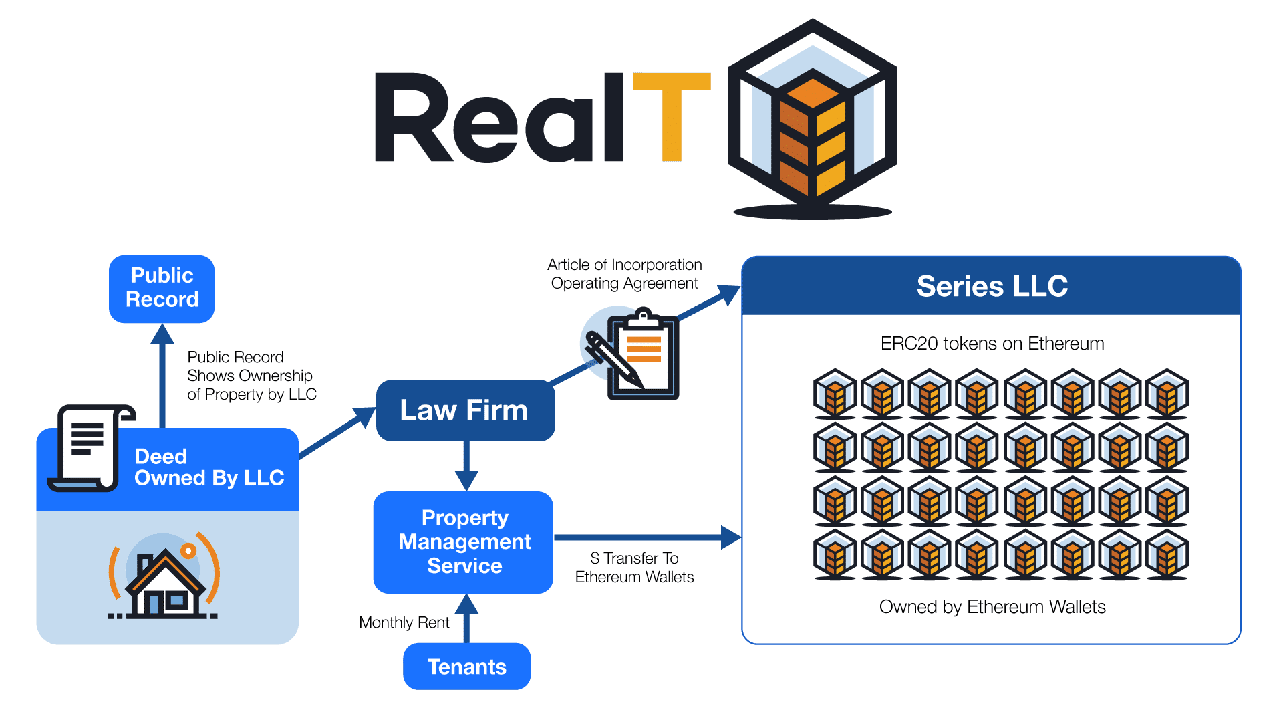

Source RealT 2021

## **The RealT portfolio**

We started tracking Real T in late November 2020. At that time, there were 19 properties in the inventory. This grew to 35 properties by January 20, 2021. By February 10, 2011 there were 43 properties in there, with several being added every week or two. Our recent interview with the Rea;lT founders revealed that they had about 70 properties as of March 5, 2021. Most of the properties are in Detroit, Michigan. Exhibit 6 shows the profile of the current RealT portfolio, broken down into the Detroit single family/doubles and other (a few apartment buildings and detached houses outside Detroit).

Exbibit 6: February 2021 RealT Listed Property Portfolio (top panel - data, bottom panel - property maps)



The RealT portfolio is pretty typical of an inner-city market: properties often have 3 bedrooms, 1.5 baths, about 1,300 square feet, are over 80 years old, and generate gross monthly rents of $870, about $0.75/SF/month. The entire tokenized price is about $66,000, and there are about 1,300 tokens priced at $53/token offered to investors. These tokens offer returns above 10%. Interesting enough, over half of the tenants in these rentals are Section 8, which could have major upside implications for stable cash flow, low turnover and cash flow stability. The properties outside Detroit are small apartment buildings, (average of 10 units per property), with average unit size of about 800SF, with similar rent and tenant profiles. Those deals had a tokenized value of about $430,000 and offered 5,600 tokens (average cost $85) per property to investors, at slightly lower, but still healthy returns.

## **The buy and getting the property into the Real T inventory**

There are two parts to this analysis. First is the buy and listing the property, followed by its ongoing cash flows offered to investors. On the buy (individual property origination side), the typical single-family property had a RealT syndication value of about $65,000. However, cross-checking the property on Zillow showed that the Zestimate was about half that, or $35,000-$40,000. The same property would likely have the same rent on Zillow and in the RealT offering statement of $850 per month. Thus, it appears there is substantial upside in listing the property on RealT (basically flipping it), and this is corroborated by the following assumptions. Even after allowing for $10,000 for repairs and upgrades, marketing and financing costs, seeding property maintenance funds, a one-time Real T syndication/tokenization fee of 5%, the potential unleveraged profit margin is about 18%, a nice return. This is detailed later in the top left side of Exhibit 8. RealT works closely with owner/developers, who generally do not act as property managers, which is considered a specialized field. Section 8 tenants are a niche market, with stable cash flows and high property maintenance requirements from constant government testing. These Section 8 properties require large reserves, which are sequestered on a property-by-property basis. RealT can manage the float on these funds, often at desirable interest rates (currently short-term rates in the 5-10% range), in crypto markets. At this point, RealT is being selective on which properties get into their portfolio, and they must all be leased, in very good physical condition, and have maintenance reserves set aside, especially if their tenants are Section 8. They also try to have more than one property manager in each city, as a back-up.

Once the property is listed, rents from a fully-occupied property support a projected rate of return, after property taxes, maintenance, marketing, a vacancy allowance, and a Real T service fee of 2%, and a management fee of 8%, that likely accrues to an outside property management company[3]. The available net cash flow of $7,300/year is distributed to token owners in proportion of their ownership in the property. See Exhibit 7.

Exhibit 7: Single Unit Cash flow Example offered to Investors



Source: RealT

## **Scalability of the RealT model**

Having set the basic assumptions, we now examine how scalable this model is for both the originator/developer and RealT the blockchain company. For the originator/developer, we assume they operate in a metro area they know well. We assume they can select appropriate houses or apartment buildings, buy properties at or below market prices, and can rehab units, obtain financing if needed, market the units and fill them. Although it is possible that they could do property management, we assume they do not. Each unit should take three months or less to acquire, do the physical rehab work, rent up and place on the blockchain. We assume the originator/developer desires to grow the number of properties on RealT to achieve cash flow. The property managers also seek some economies of scale[4].

Based on these building blocks, Exhibit 8 shows the scalability of the RealT model. We examine returns to the originator/developer on the left side, and the top left quadrant restates material presented above for a single unit, and expands it for 10, 25 and 100 units. We address both cash flows for the original placement/development, and ongoing cash flows from property management. Note that by the time the originator/developer places the property on the blockchain, they have cashed out, and unless they own tokens, they have no money left riding on the property, just the opportunity to have some (likely other) entity manage the unit for a fee. From the developer’s perspective, most of the money is in listing the properties (shown above the bottom black line) rather than ongoing management (at the bottom of the left side). Each property has a large profit (estimated at 18% using these assumptions) for “flipping” the property onto the blockchain. The property manager would need 100 units to net $50,000 a year on those fees. The items in red show RealT’s take, both on origination, and for ongoing servicing.

On the right side of Exhibit 8, we show RealT’s earnings, at a larger scale since they are presumably doing this in numerous markets. Likewise, the bulk of their funds comes from the one-time-per-property listing/securitizing fee. At 1,000 units under management, the fees they’d make (over $3 million) looks like it could support a business nicely. Other income comes from the ongoing service fees, and from the float on numerous sequestered property maintenance funds, which can currently generate 5-10% returns per annum on short term loans, on the crypto markets.

Finally, at the bottom of Exhibit 8 we combine these growth scenarios over a five-year ramp-up period for both the individual originator/developer. For the city-originator, we assume a steady increase to adding up to 30 new units a year onto the blockchain, also yielding a total of about 100 total units under management by year 5. The revenues do look sustainable, and could likely support a few employees, although the mix of revenues from origination rather than management stays quite high, at almost 90%. Further, net revenues from property management are only about $60,000 a year. To do “real” money (not RealT), the entrepreneur would likely have to grow faster than we show here. On the other hand, if originator/developers tokenize apartment buildings rather than houses, or if the houses are more expensive and can still generate adequate returns such that investors would buy the tokens, then the revenues would certainly increase.

From the perspective of RealT, we assume they can add five cities (each having an originator/developer performing similar to that shown on the left side panel) a year, up to a total of 30 urban markets within five years. That gives them 900 (single family sized) properties on the blockchain from all sources by year 5. Using these assumptions, they break $1 million by year four, and have a nice upward trajectory after that. If their originator/developers tokenize more expensive property (e.g., apartment buildings) and can still generate adequate returns such that investors would buy the tokens, then the revenues would certainly be higher.

Exhibit 8: Scalability of the RealT Model



## **SECONDARY AND INDIRECT BENEFITS OF THE RealT PROGRAM**

Detroit is not alone. Cities like Cleveland, Buffalo, St. Louis have stable rents and declining asset values due in part to negative population growth. These markets can offer a high cash-on-cash return to real estate investment, and easily hit the 10% threshold attractive to online token investors. There are likely dozens of markets in the US where the RealT concept could be replicated, and in larger markets there could be room for more than one local originator/developer.

Since the typical Zillow market price of an asset in the RealT portfolio appears to be about 50-75% of its securitized price (but rents are about the same), there are a number of implications. First, obviously, there is a profit potential for the investor to acquire the property, get it fixed up and leased up, and flip it into the RealT online portfolio. The value-add here seems to be both the physical/rent-up, but also that securitizing it allows a way to find token investors that increase the asset price, and still produce 10%+ returns. Still, property maintenance funds and other items dilute the return at the origination phase.

But bringing residential properties into the RealT portfolio also potentially increases property values in the inner city: these sales are legal and registered with the local authorities, and appraisers can use them as comps in valuating nearby properties. This assumes substantial appreciation/value-add between the first (original acquisition off the market) and second (finished unit, rented and placed into a property-specific RealT LLC) transaction. Thus, this could swing the house price pendulum back toward higher values, larger mortgages, and higher net worth for owners of inner-city residential property. This is a good thing[5]. Increasing inner city property values has been a thorny, even a vexing societal issue, and also directly affects wealth creation among African-Americans and other minorities (Perry, 2020, Chapter 2). Buying up real estate with interested capital partners could help stabilize and redevelop neighborhoods and fuel appreciation in property values. Perhaps investment in RealT could also satisfy a Bank’s CRA (Community Reinvestment Act) requirements.

Another intriguing observation is the prevalence of Section 8 tenants in the RealT portfolio. This type of tenant tends to be very stable, so rental turnover is minimized, and the required property quality adds a sense of oversight and assurance that the property conditions are maintained. In a sense, RealT could be looked as a type of Section 8 secured portfolio, backed indirectly by the US government. However, there are added expenses because these properties require a larger property maintenance budget, and attention to more frequent government inspections.

# **RealT capitalizes on the structure of decentralized finance.**

Benefits of transparent blockchain investments: All transactions data are public. Transparency in pricing assets, including buying, selling, rent payments, amounts and participants, primary market, secondary market with live secondary pricing data, and transparent visualization of dividends and liquidity in real time. It also offers automated Market Makers, with potential to receive profits of bid ask spread, where must place both buy side and sell side orders and large amounts of liquidity including Bid-Ask spread are shown. Finally, dividends are paid without ex-dividend date, where those who own at payment time receive payment, without any unwieldy prices swing to calculate expected dividends.

See: Appendix A

# **CONCLUSIONS AND FUTURE RESEARCH**

Blockchain technology is a platform for transactions and investment. It includes crypto currencies, of which there are dozens of investment vehicles, of which Bitcoin and Ethereum are the best known. Crypto is an emerging asset class, and offers some portfolio diversification benefits, as well as attractive rates of return, subject to “translation” or conversion back into underlying currencies like the US dollar. Blockchain allows ease of access and transparency, but also provides a cloak of anonymity, which may be incompatible with owning real estate, which generally has ownership and transactions as public records. Everything is hidden in plain view.

This paper has provided a primer on the intersection of blockchain, cryptocurrencies and real property, and reviews the various ways that these emerging technologies and instruments are used in real estate investment today. We did a case study of a blockchain-oriented investment platform called RealT. Their business model and customer-servicing interface appears to be sustainable for token buying investors, originator/developer partners that list and manage the properties, and for the parent company that provides a marketplace where properties are tokenized on the blockchain with smart contracts. We look ahead to ponder future directions over the next 5 years where the best qualities of cryptocurrency and real estate overlap and may form a robust and sustainable investment environment.

Some loose ends: We are not sure of exit strategy for owning these houses. Perhaps you just sell your tokens, or one owner can accumulate tokens, likely at a reduced price, maybe after a non-payment event (say vacancy), above and beyond the 9.9% ownership cap. Still, it seems like the house itself is forgotten, and it’s unclear if the fairly modest 5-8% management fee is enough to keep someone focused on repairs and lease up when owners are scattered to the four winds, and anonymous.

One answer may be to get neighborhood community development corporations (CDCs) groups involved. They are in it for the long haul and building up their turf with RealT could be an attractive way to build their balance sheet, get a property management fee, and build up and maintain their territory. If token prices drop, or even if they do not, CDCs could acquire them and hold ownership, or even pass it off to tenants on the secondary market.

Also, rental property generates an annual depreciation allowance of 3.63% of the non-land part of the property. For US investors, this tax advantage is processed, but it is uncklear if these benefits flow through to token holders in a 1099 format. For Reg S foreigner investors, depreciation is left on the table, and in the future, it could be monetized by RealT at the corporate or LLC level. We are not sure how this is allocated. Maybe after income tax time, I’ll find out since I own a few tokens in a Detroit RealT house.

While RealT founders were lukewarm on the pure profit between the first and second transactions of the originator, a careful buyer could likely beat the 18% returns in a loose housing market. Thus, the potential for upside arbitrage in house prices could be great that is modeled here.

Future research includes secondary market for tokens, more volume on RealT, other similar firms, creating a token index, and watching to see within a few years if local house prices creep up. Finally, more thought needs to be put into the apparent fact that RealT is essentially a Section 8 backed Security and related implications.

# REFERENCES

**In order, exclude stuff we do not use, include stuff we cite**

Robert Leshner and Geoffrey Hayes. Compound: The Money Market Protocol. Feb. 2019. url: [https://compound.finance/documents/Compound. Whitepaper.pdf](https://compound.finance/documents/Compound.%20Whitepaper.pdf).

This whitepaper was the beginning of compound finance, an algorithmic money market protocol that lets users lend and borrow idle assets in the blockchain. Utilizing a new coding language at the time, solidity, Hayes, Leshner and Compound Labs, created a platform with over $10 billion locked in as of March 5, 2021. On compound Finance there are three stable stablecoins, or digital dollars with active money markets, enabling users to deposit bitcoin, ether, and few other assets to borrow and lend effetely allowing users around the world leverage their investments and access capital. While Compound Finance was certainly not the first Decentralized Finance project and will not be the last, the team’s willingness and promotion of community governance has created a new era of “self-driving banks” this is good, put in body of paper

*Hayden Adams. Uniswap. url:* [*https://uniswap.org/docs/*](https://uniswap.org/docs/)

Born out of the ICO (Initial Coin Offering) era which lead to Bitcoin’s large crash in 2018, authors of the Uniswap Whitepaper created the frameworks to allow for algorithmic, decentralized exchanges. Instead of utilizing orderbooks as traditional exchanges do, Uniswap allowed third parties to provide and remove liquidity to markets, without any governmental regulation or regulations. Prices are determined by a constant product formula, relying on liquidity providers and arbitragers to keep the market in equilibrium.

<https://dashboard.realt.ch/map> This website uses public blockchain data to create an interactive dashboard for RealT investors and those curious. Provides maps, trading data and rental disbursements.

<https://defipulse.com/> Data aggregation website putting together all financial holdings of decentralized finance platforms.

Perry, Andre. 2020. Know Your Price. Washington DC: Brookings Institution Press

Schär, Fabian & Schuler, Katrin & Wagner, Tobias. (2020). *Blockchain Vending Machine: A Smart Contract-Based Peer-to-Peer Marketplace for Physical Goods.*

*Vitalik Buterin et al. 2013. Ethereum white paper. GitHub repository (2013)*.

<https://www.coindesk.com/bloomberg-terminal-lists-ethereum-based-debt-instrument>

<https://withcadence.io/blog/>

<https://www.centre.io/usdc>

<https://www.paxos.com/paxgold/>

RealT. Legally Compliant Ownership of Tokenized Real Estate. White paper. <https://realt.co/education/> last accessed February 23, 2021.

https://cointelegraph.com/news/comparing-money-laundering-with-cryptocurrencies-and-fiat

<https://www.jpmorgan.com/commercial-banking/solutions/commercial-real-estate/community-development-banking/community-development-banking-faq>

<https://www.jpmorgan.com/commercial-banking/solutions/commercial-real-estate/community-development-banking/new-markets-tax-credit>

<https://www.policymap.com/2015/07/mapping-cra-eligibility/>

<https://dashboard.realt.ch/map>

<https://www.policymap.com/2015/07/mapping-cra-eligibility/>

<https://www.cnbc.com/2019/08/01/goldman-spending-100-million-to-shave-milliseconds-off-stock-trades.html>

https://www.curve.fi/stableswap-paper.pdf

<https://uniswap.org/whitepaper.pdf>

<https://aave.com/>

# APPENDIX A : TYPES OF DOCUMENTS AVAILABLE TO REALT TOKEN HOLDERS ON THE BLOCKCHAIN IN REAL TIME

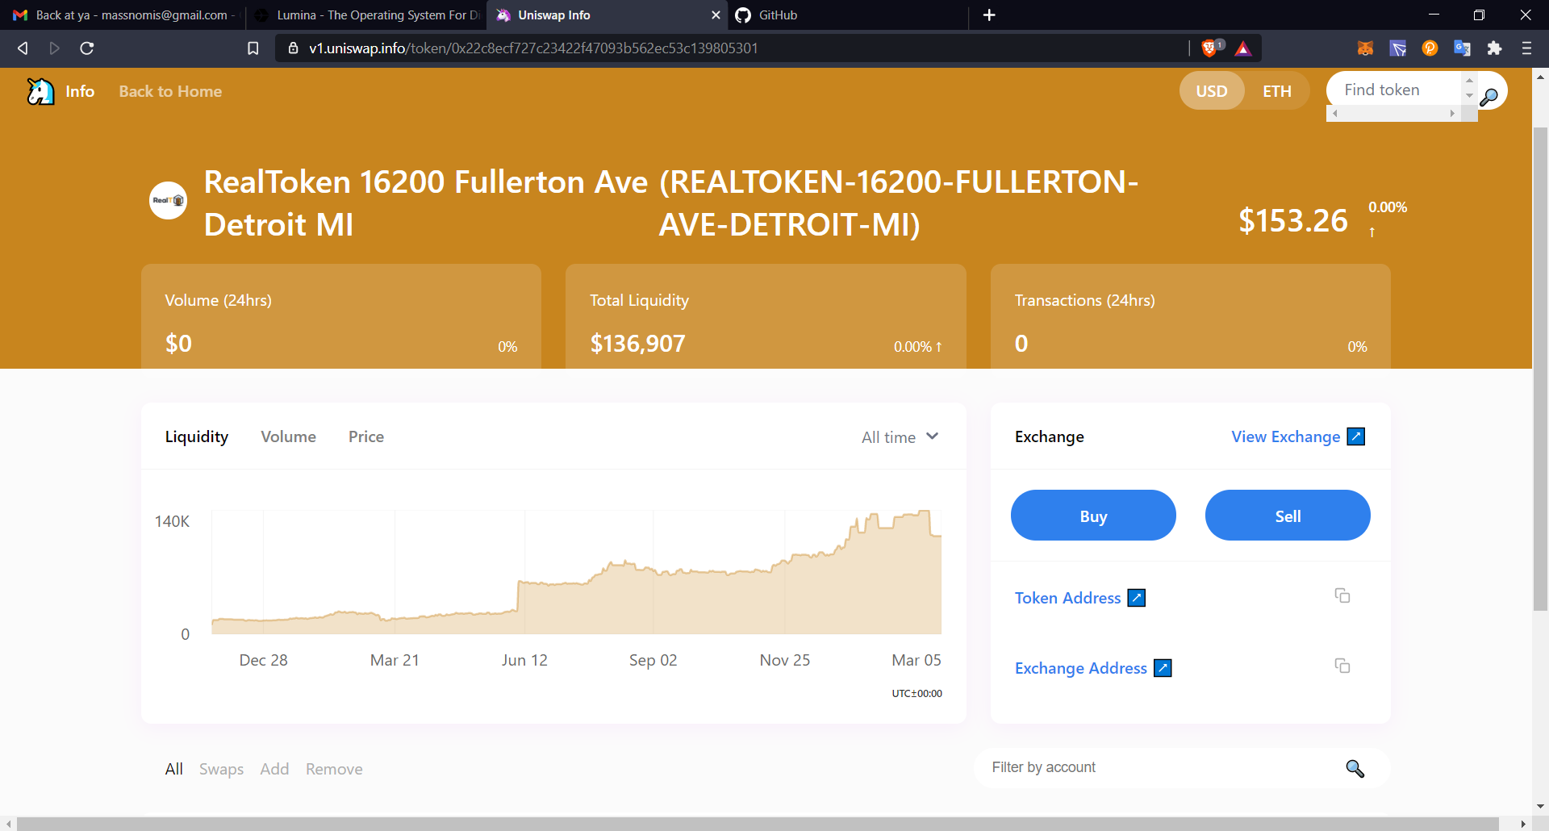Eth price changes bring volume and liquidity

Asset transparency

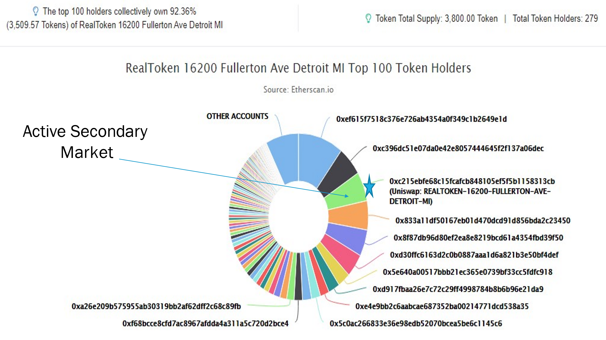

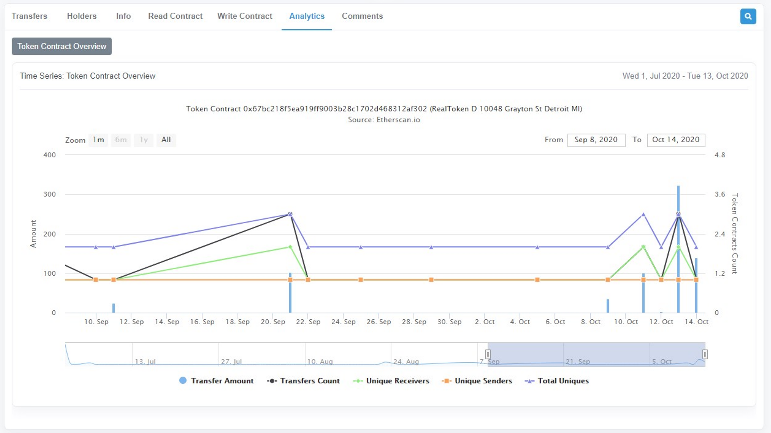

RealToken analytics, sends, trades, buys, contract interactions

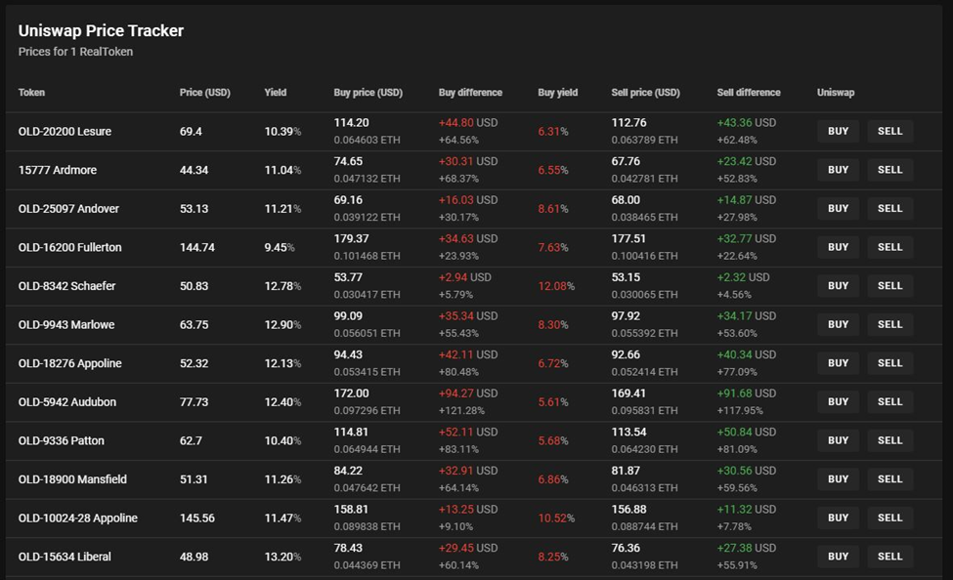

Trading dashboard, with yields included, price as bonds

1. Further, at least at this time, RealT offers some “guaranteed buyback” provisions, though it is unclear how sustainable these are in the long run.
2. The types of reports available to investors on ownership, distribution of cash flows and other items are remarkable and numerous. They are graph based, and show all the property’s expenditures, but everything is anonymous, as owner units are identified by numbers not by name. They are updated in real time and are remarkably transparent.
3. The RealT contract calls for a slightly lower cut, but also allows for additional management fee for distributing maintenance funds.
4. Zoom interview with Remy and Jean-Marc Jacobsen, RealT Principals, March 5, 2021.
5. On the downside, if property values go up, so will property taxes, so some people will complain about that.